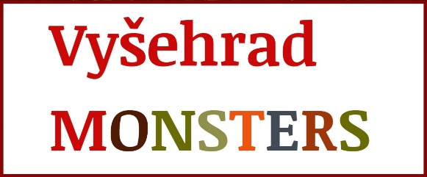

APPLICATION FOR ENROLLMENT
ENGLISH OUTDOOR PRECHOOL VYŠEHRAD MONSTERS

Operator:
All4kids, z.s. (IČ 22771611)
Address: U Libeňského pivovaru 31, 180 00, Praha 8
Account number: 2500191607/2010
Statutory: Barbora Drážníková

Preschool address and contact:
Na Pankráci 22, Praha 4 - Nusle
info@vysehradmonsters.cz
607 757 816

Attendance type:

☐ Monsters (3 – 6 years)
☐ full program (whole week)
☐ 4 days a week, please specify:
☐ 3 days a week, please specify:
☐ Baby Monsters (18 months – 3 years)
☐ whole week, all-day (8:00 - 15:30)
☐ whole week, half-day (8:00 - 12:30)
☐ 4 days a week, all-day (8:00 - 15:30) - please specify:
☐ 4 days a week, half-day (8:00 - 12:30) - please specify:
☐ 3 days a week, all-day (8:00 - 15:30) - please specify:
☐ 3 days a week, half-day (8:00 - 12:30) - please specify:

Name and surname of the child: Klikněte sem a zadejte text.

Date of birth: Klikněte sem a zadejte text.
Place of birth: Klikněte sem a zadejte text.
Personal ID: Klikněte sem a zadejte text.
Health insurance: Klikněte sem a zadejte text.
Address: Klikněte sem a zadejte text.
Nationality: Klikněte sem a zadejte text.

Application for enrollment of the child for attendance starting from: Klikněte sem a zadejte text.

Parents (legal representatives):

Name and Surname: Klikněte sem a zadejte text.
Date and place of birth: Klikněte sem a zadejte text.
Address: Klikněte sem a zadejte text.
Occupation: Klikněte sem a zadejte text.
Contact phone: Klikněte sem a zadejte text.
Contact e-mail: Klikněte sem a zadejte text.

Name and Surname: Klikněte sem a zadejte text.
Date and place of birth: Klikněte sem a zadejte text.
Address: Klikněte sem a zadejte text.
Occupation: Klikněte sem a zadejte text.
Contact phone: Klikněte sem a zadejte text.
Contact e-mail: Klikněte sem a zadejte text.

Information about the health condition of the child (tick):

☐child is healthy
☐child requires special care in the area (tick and specify):
☐medical: Klikněte sem a zadejte text.
☐sensorial: Klikněte sem a zadejte text.
☐physical: Klikněte sem a zadejte text.
☐dietary: Klikněte sem a zadejte text.
☐other: Klikněte sem a zadejte text.

Other information about the health condition:
allergies: Klikněte sem a zadejte text.
permanent medication: Klikněte sem a zadejte text.
other limitations: Klikněte sem a zadejte text.

Parent claims, that the statement on the health condition of the child, which is a condition for enrolling the child for attendance, contains accurate, truthful and complete information.

In Prague on …………………. ……………………………………… signature of parent / legal representative

……………………………………… signature of parent / legal representative

